# deAttribute List

Each entities have a primary key which will be underlined. Each entities have exactly one primary key. Attributes can have more than one primary as combos which represents itself as a singular primary key.

Primary key=attribute

### **Study**

Name

Description

Part time

Language

No of years

### **Course**

Name

Description

Study

Teacher

Credits

### **Teacher**

First Name

Last Name

Date of birth

Nationality

Street

Street number

Postal code

City

Phone number

Email

Work Email

Gender

Salary

Study counsellor

Teacher number

Password

### **Student**

First name

Last Name

Date of birth

Nationality

Gender

Street

Street number

Postal code

City

Phone number

Email

Study

Part time

Start year

Study counsellor

School email

Password

Student number

### **Exam**

Course

Room

Resit

Date

Time

### **Result**

Grade

Exam

Student

Passed

Weight

Date

**Enrolls**

**Contains**

**Teaches**

**Has**

**Has**

**Has**

**Produces**

**Counsel**

**Entity-Relationship Model**

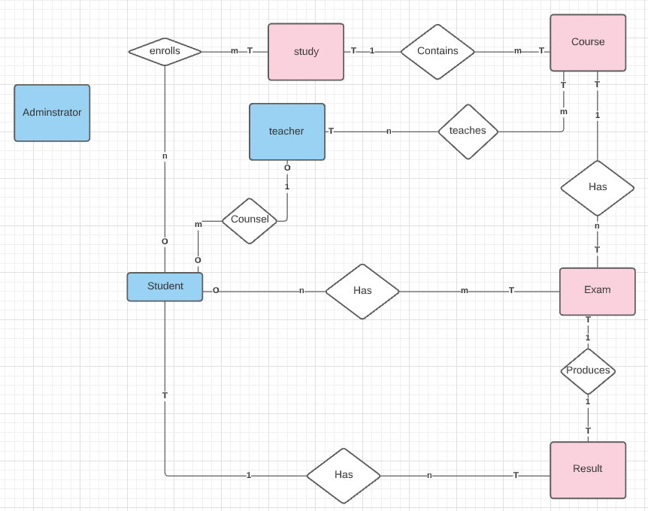

Link to our Entity-Relationship Model: <https://lucid.app/lucidchart/invitations/accept/inv_d4d51a41-5f4e-4061-9011-a1b381a86563?viewport_loc=-79%2C-713%2C2560%2C1234%2C0_0>

**Bachmann Diagram**

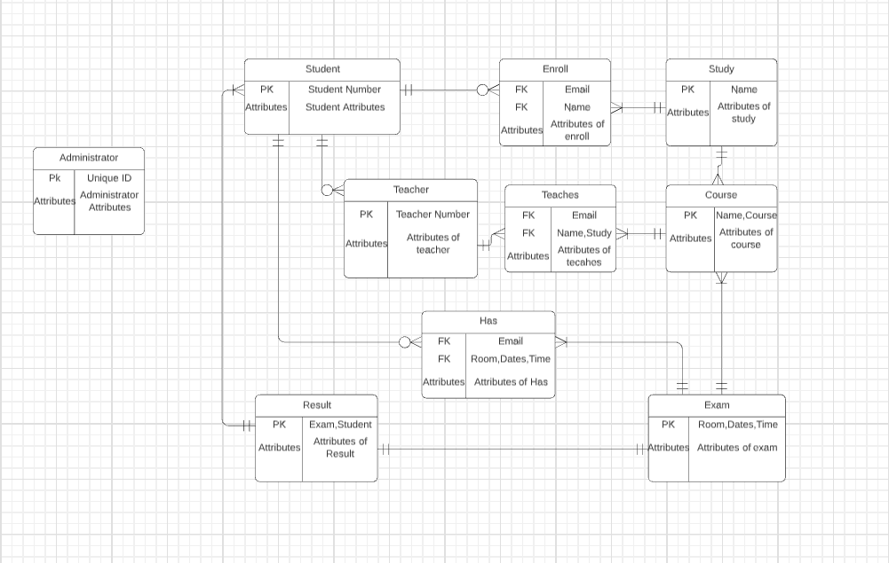

Link to our Bachmann Diagram:

[Bachman Diagram : Lucidchart](https://lucid.app/lucidchart/f2ea0d1c-a6bf-46d2-989e-64c66ec51e9a/edit?page=0_0)